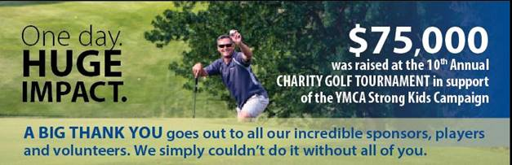

Thank you so much for supporting the 10th Annual Charity Golf Tournament. Your involvement kept this event right on PAR! The golf tournament was a HUGE success because of your generosity, hosting over 144 golfers at a world-class course and engaging all local media.

With your participation and tee/green sponsorship, the 10th Annual Charity Golf Tournament collectively raised **$75,000**!!! ***YOU helped make this possible.***

All proceeds will benefit the YMCA’s Strong Kids Campaign. 100% of every dollar raised stays local and supports children and families living in the Okanagan. By being a part of the day, you have helped to ensure hundreds of underprivileged and vulnerable children and families can access YMCA programs such as child care, day camps, aquatics, employment readiness and before & after school enrichment programs.

Please **save the date** for 2020 as the 11th Annual Charity Golf Tournament will take place on July 20. You will have the first opportunity to return as a player and/or a sponsor. We will be in touch early next year to confirm your involvement.

On behalf of the Tournament Committee and the YMCA of Okanagan, **THANK YOU** again for your support and generosity.

Sincerely,

*Alli McNeill & John Weisbeck; Co-Chairs  
Bruce Walker David Walker, Steven Pavelich, Marshall Peters, Bear Capozzi, Gino Dal Ponte, Mark Nonis, Kate de Kruif & Rhonda Zakala; Committee Members*

